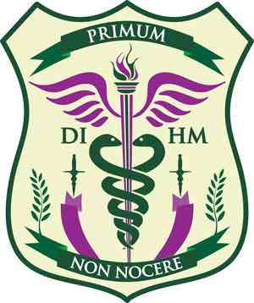 | University of America (Curacao & Florida USA)

Application Form for a) Bachelor b) Master c) Doctorate
In Naturopathy & Holistic Medicine, awarded by the University of America, College of Natural Sciences

Applicant Information
Full Name: |  |  |  | Date:
 | Last | First | M.I.

Address:
 | Street Address | Apartment/Unit #

 | Country City | State | ZIP Code

Phone: |  | Email

Gender: |  | Nationality: |  | Date of birth:

Marital status:

Proficiency in English (Spoken): | YES | NO | Proficiency in English (Written): | YES | NO

Do you have any education in the biological sciences? | YES | NO | If so, what?

Have you ever been convicted of a felony? | YES | NO

If yes, explain:

Education
High School/College:

From: |  | To: |  | Did you graduate? | YES | NO | Diploma:

University:

From: |  | To: |  | Did you graduate? | YES | NO | Degree:

Other:

From: |  | To: |  | Did you graduate? | YES | NO | Degree:

Hobbies/Interests

Previous Employment
Company:
Address:

Job Title:

Responsibilities:

From: |  | To: |  | Reason for Leaving:

FEES

Are you personally responsible for paying your fees? | YES | NO
PERSONAL STATEMENT – write a few lines expressing your interest in studying Holistic Medicine and why

Disclaimer and Signature
I certify that my answers are true and complete to the best of my knowledge.

Signature: |  | Date:

Please also send your CV or resume when returning this form to admin@collegenaturalmedicine.com

